Cover Sheet for Governing Body Meeting Papers
Paper Number (Agenda Item): | 6 D i
Board/Committee: | Governing Body Committee
Date of Meeting: | 27th December 2019
Subject: | Treloar School Primary Sports Fund report 2018 - 19
Author: | Laura Coleman. PE Teacher
Date of Paper: | 7th October 2019
Linked to which of the Treloar’s Values: | - Acting with integrity  - Commitment to delivering excellent services.
Linked to which of the School and College Strategic Plan Aims: | - To deliver outstanding provision that enables students to achieve the best possible outcomes  - To ensure that student recruitment delivers a sustainable future for the School and College. To ensure that all potential beneficiaries of the provision at Treloar’s are made aware of the offer and are given the support they need to give them the best chance of accessing it.
Key Points to Note: | - £15,000 fund was used for 14 Primary students in 18/19  - This report provides:  - Details of what the fund were spent on  - The purpose of those activities  - The impact this had on the students learning experience and/or progress  - The end of the report shows some picture of the students using the various resources described within this report
Recommendation : | Members are asked to (delete as appropriate):  - Note

Treloar School Primary Sports Fund report 2018 - 19
Academic year | 2018/19
Numbers of students in receipt of Primary Sports Fund | 14
Total amount of funding received | £15,000

Resource | Objective | Items | Cost | Impact
Stopgap dance workshops | To inspire students in the area of inclusive dance and link in with class topics. | Dance workshop | £150.00 | Students were able to learn new skills, learn to work as a group, build confidence and experience performing arts.  Dance is offered on the PE curriculum but it is not ran by a subject specialist in dance. Students were able to learn fairy tales which they had been looking at in class within a practical environment and transfer the learning.
Molift Folding Hoist | To allow students to use trikes and walkers within PE lessons for races, games and competitions.  To allow students the opportunity to get out of their chairs for games and activities on the parachute and for massage sessions. | Portable Molift Folding Hoist | £1913.25 | Able to take students out of their chairs and hoist them onto trikes and into walkers in PE. Before students had to go to classrooms with built in hoists and there wasn’t time. There is now time with the portable hoist  Also, allow them to experience the sensory benefits of the parachute by lying on the parachute.
Wet Wheels/Sailing experience | To allow the students the opportunity to experience trips off site.  Students to experience the wind, sea and driving a boat.  To socialise with members of the community. | Day out sailing | £1,000 | Students relish the time spent on the boat and gain so much from experiencing what other young people get the chance to do with their families. The reason these trips are so important is that often families are not able to take their disabled children away for a variety of reasons and by being offered it through the school it makes it far more accessible as we have the staff to support the students on these trips and also the transport available to get them to the activity. Furthermore, the children ae being taken out on the boat by experienced sailors that are familiar with working with young disabled students and understand their needs and the pace that the students will be working at along with the safety measures that are in place to make this possible. During our Primary Student Council meetings activities were discussed for the coming year and sailing was one of the things they said they would like to experience again.
A range of PE equipment for Primary PE lessons. | To engage students in a variety of sports that they may not have had access to before.  Allow all students to take part practically in lessons so there is less waiting around.  Students to take on various roles in PE as well as a performer such as an official. | Boccia balls x 4  Boccia callipers x 4  Kurling stones x4  Kurling scorecards x 2  Polybat bats  Wheelchair footballs  Scoreboards x 2  Throwing targets  Timers and stopwatches  Orienteering set | £3,339.00 | Students are able to access inclusive sports in PE lessons. Also, students are able to play a game of say polybat all at the same time, as there will now be enough equipment.  Football can be added into the primary curriculum along with more structured orienteering lessons due to the new equipment.  Students are able to learn about the role of an official and have a go at becoming the official by using the scoreboards, timers and stop watches in lessons.
Trike and walker to increase physical movement in physio and PE lessons. | To allow the students the opportunity to get out of their chairs and trike or walk in PE and physio lessons. | KW Kidwalk Walker  Fizz Trike | £2,859.00  £2,625.00 | Students able to physically exercise by walking or triking. This gives the students the opportunity to use the racing track outside and compete on Sports day and other sporting events. This promotes independence.  Students can now be more active in PE and physio lessons.
A range of equipment to promote independence in swimming. | To encourage students to swim as independently as possible in swim lessons. | Lasal swim floats to allow students to swim more independently. | £1,455.00  £1,128.00 | Students will have the opportunity to float independently and swim as independent as possible with the help of the floats.  -Students heads will be supported more safely than any other floatation aids we already have.  They allow students to work in a variety of positions.  Maximise mobility, stability and increase comfort and provide a safe experience for the students in the water.
A range of swimming equipment for swim lessons and hydro sessions. | To promote learning in lessons through play to encourage water confidence.  To allow the physios in hydro sessions to get the students to perform particular stretches and exercises through the use of toys and pool equipment. | Foam blocks  Pool toys  Floating chair  Watering cans | £89.93
Total |  |  | £14,559.18

Plans for Autumn 2019 | Objective | Cost | Impact
Physio equipment- wedges and a trike which several of primary students can use. | To ensure primary students have individual access to a range of appropriate equipment to enable them to engage in a range of Physical activities more frequently
Aerobility workshop | To allow to experience aerobility onsite using a simulator.  To allow students to learn about aircrafts. This fits in with some of the classes topics on travel.  To meet and work with members of the community. | £316.80

Stopgap Dance
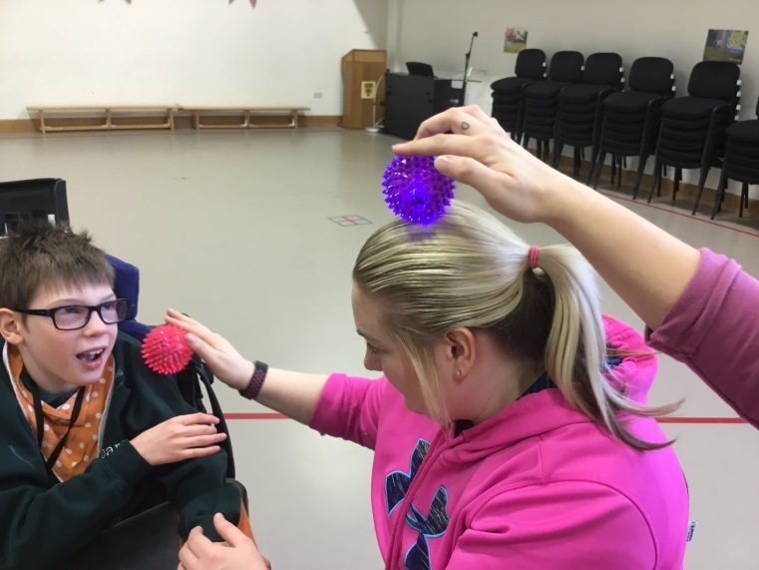
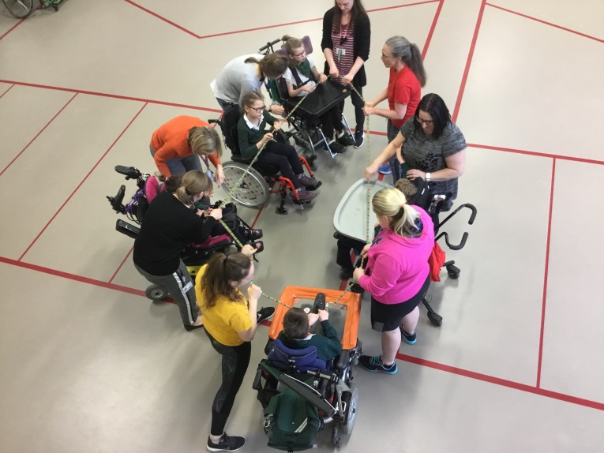
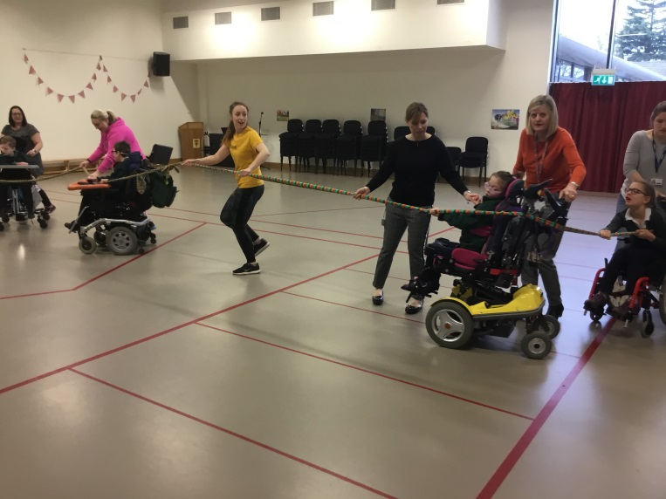

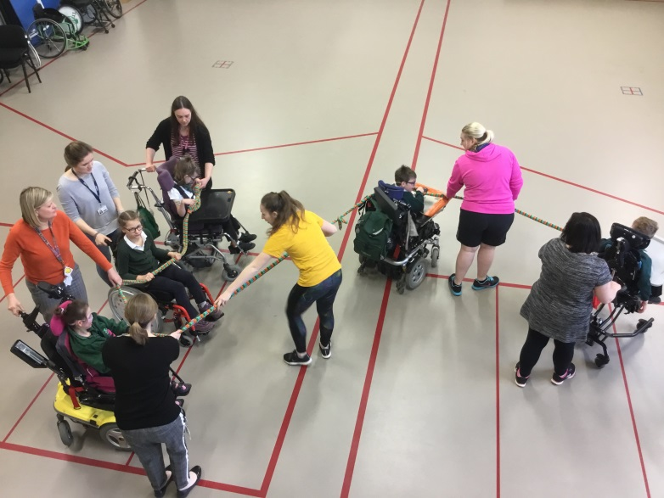
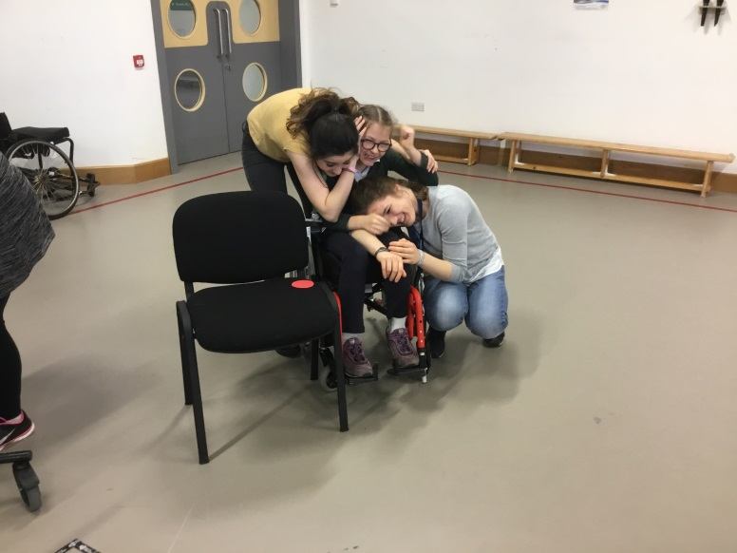
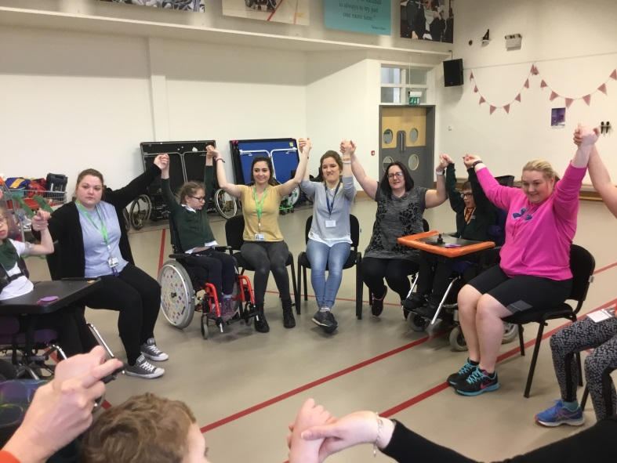

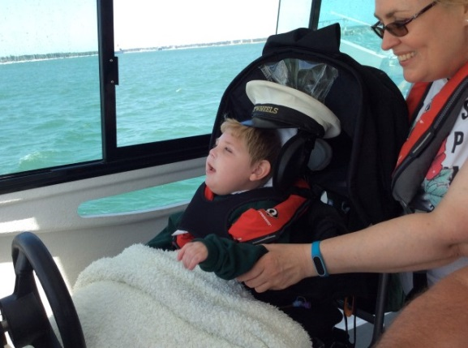
Wet Wheels
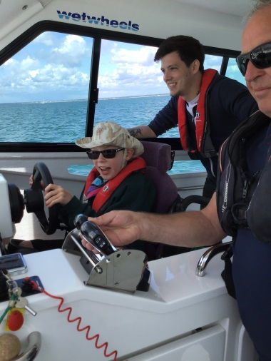
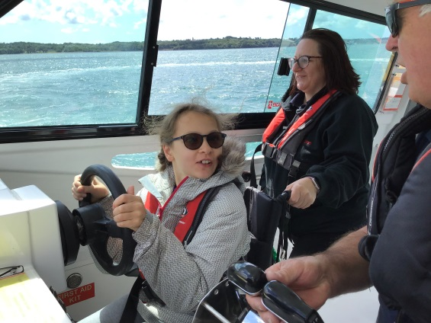
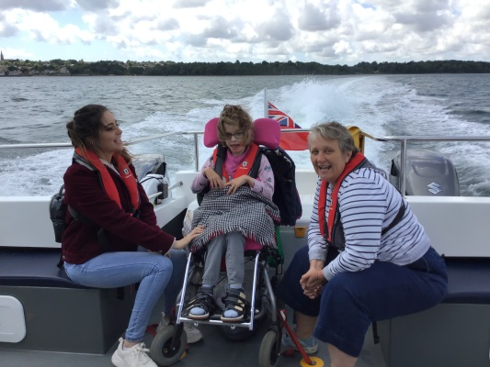
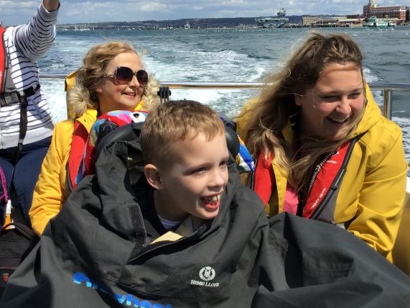
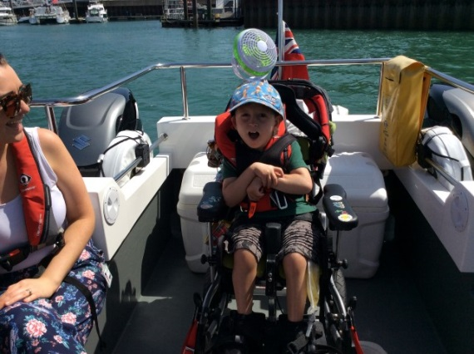
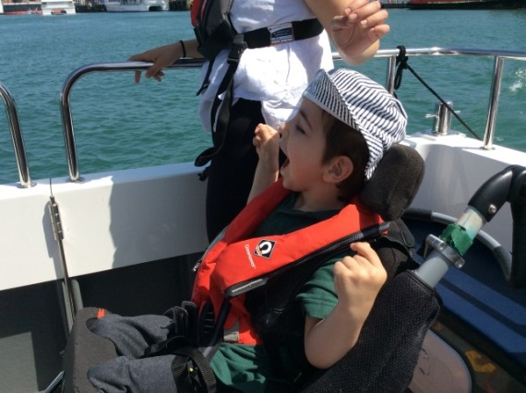
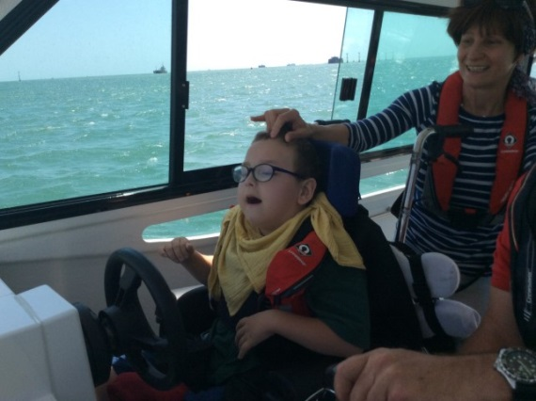
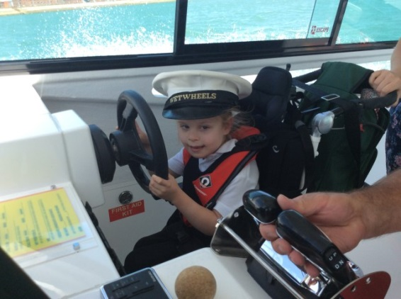
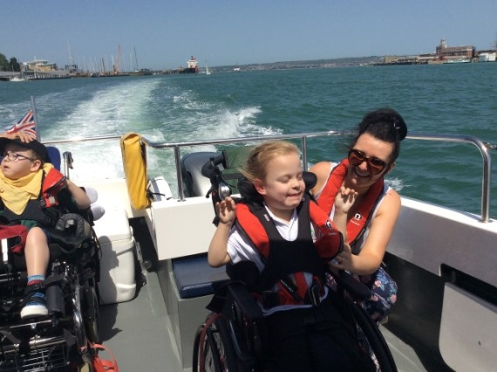

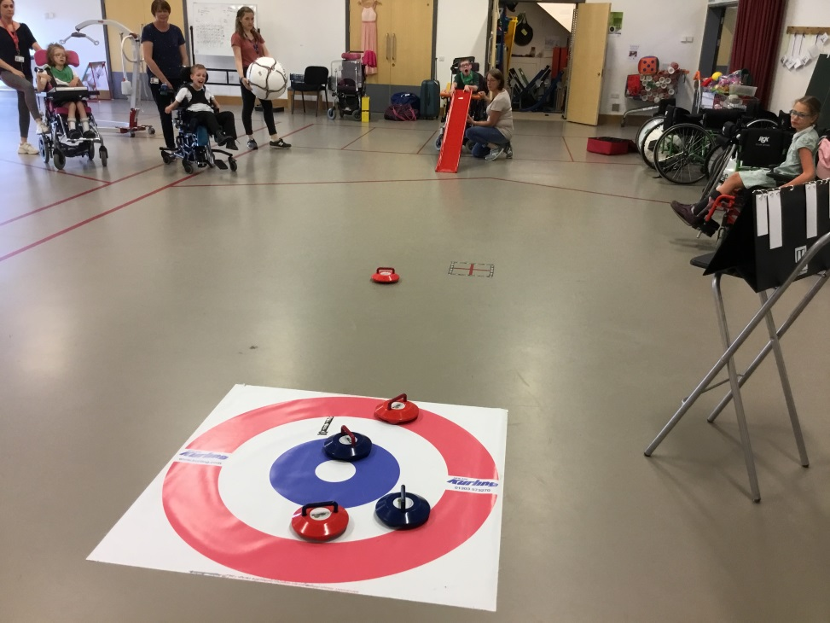
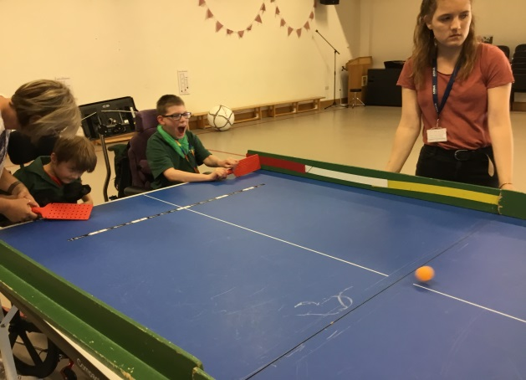
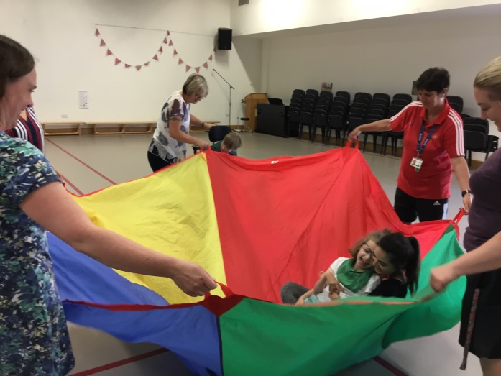
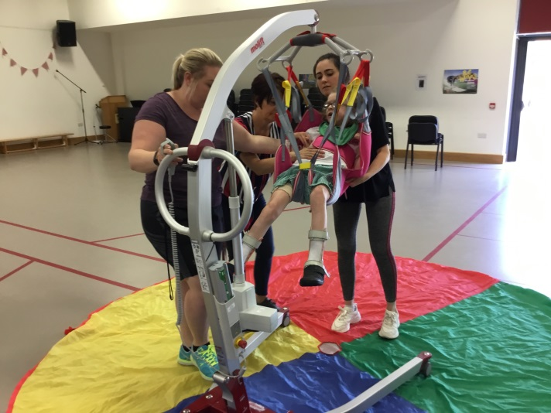
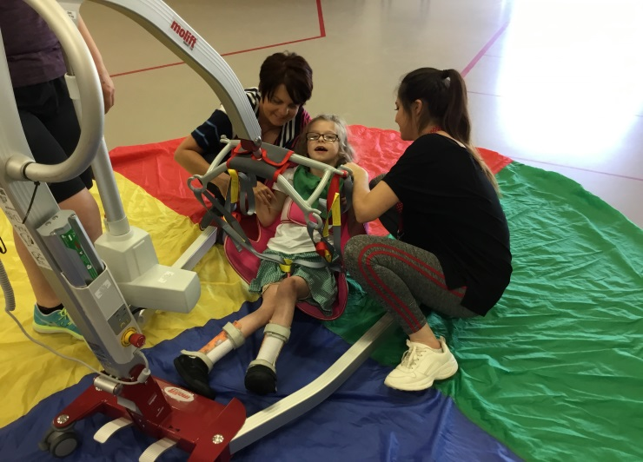
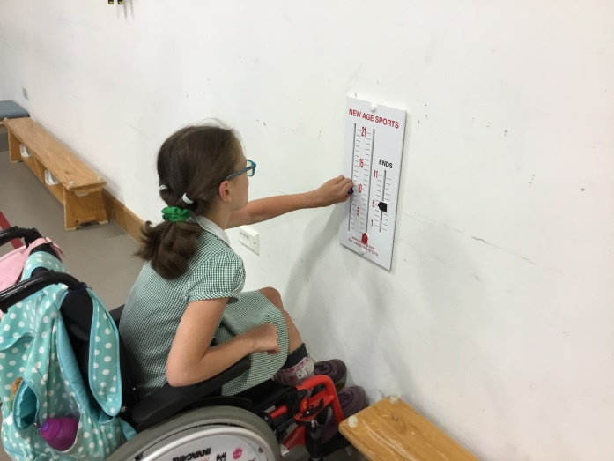
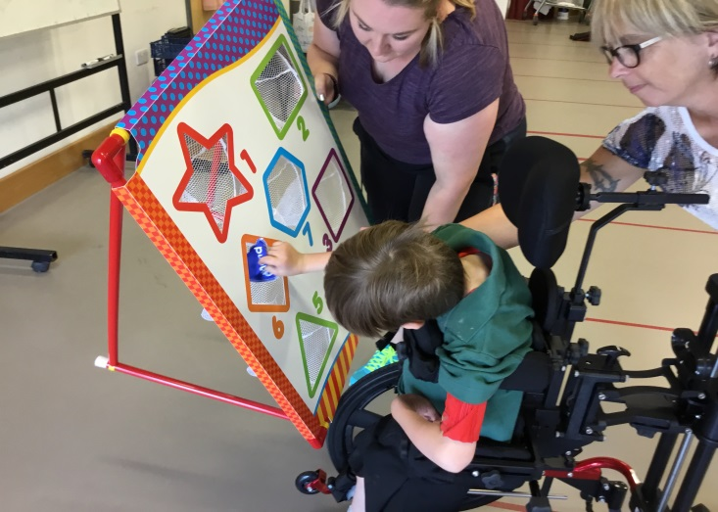
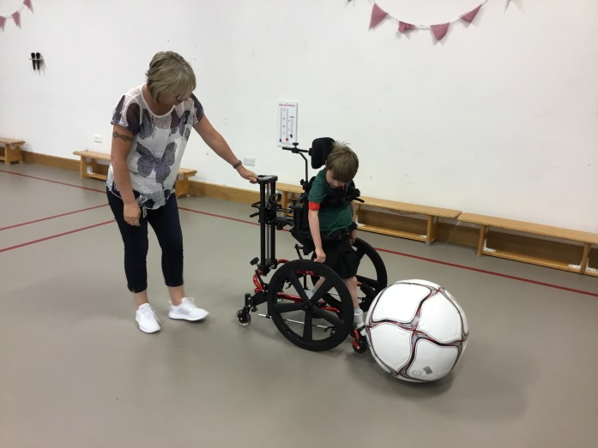
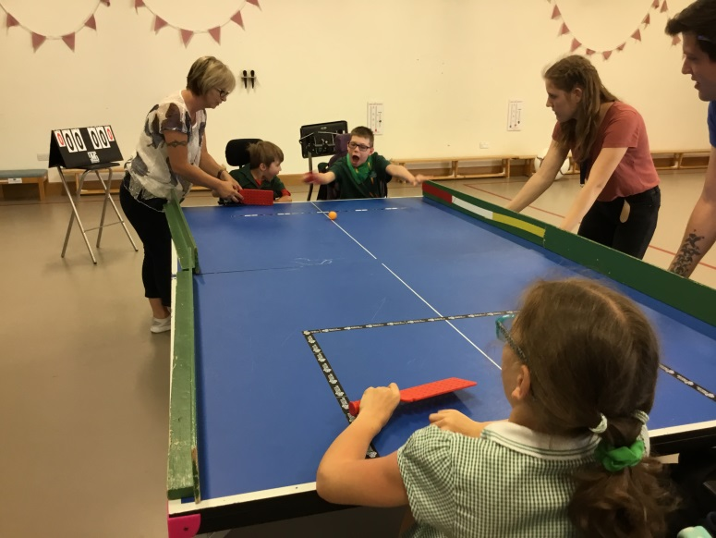
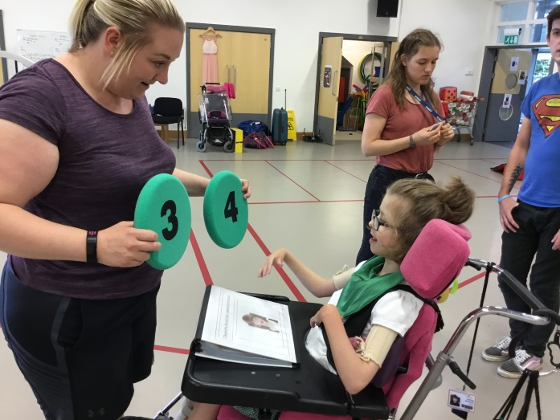
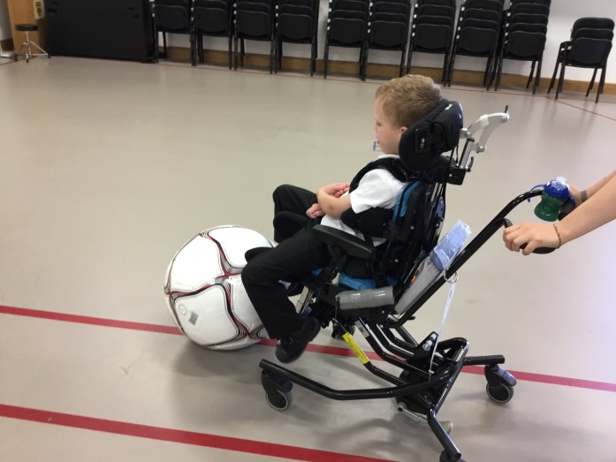
Molift folding hoist and PE equipment
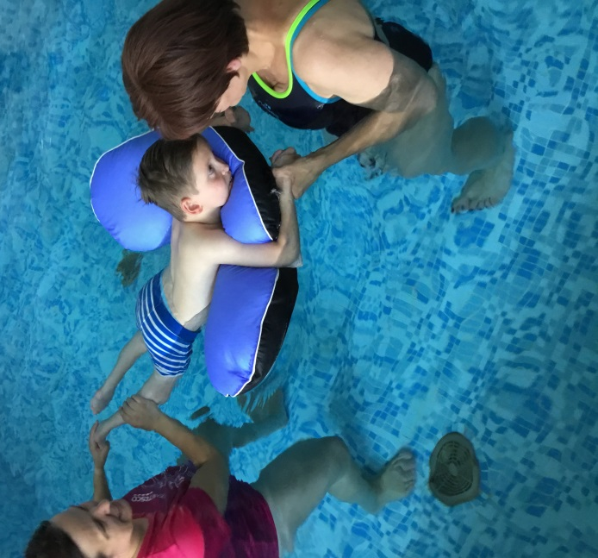
Swimming equipment
