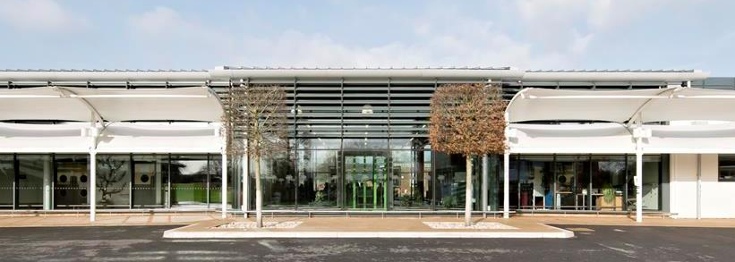

Outreach Services
Room Hire Price List
September 2019 – August 2020
Room/Facility | Seating Capacity |  | Price * |  |  | Free parking  up to 250 vehicles | Available 50 weeks  of the year
 | Theatre | U Shape /  Boardroom | Per Hour | Half Day  (4hrs) | Full Day
Conference room:  Heywood Room | 20 | 14 | £19.00 | £66.50 | £104.50 | √ | √
Training Room:  T13 | 30 | 15 | £27.00 | £94.50 | £183.00 | √ | √
Small Hall  (Chill Out Zone) | 100 | 40 | £27.00 | £94.50 | £183.00 | √ | √
Hall with stage:  FT Hall | 150 | 50 | £27.00 | £94.50 | £183.00 | √ | Half terms & holidays
Sports Hall:  Pike Hall 200m² | 250 | 80 | £27.00 | £94.50 | £183.00 | √ | √
Swimming Pool  Heated 32-34°C | Please apply for pricing |  |  |  |  | √ | √
Outdoor Multi  Use Sports Court  (suitable for 5 or 7 a-side football) | n/a | n/a | £25.75 | £90.15 | £175.00 | √ | √

*Additional charges may be incurred if required out of normal opening hours

Catering Prices
September 2019 – August 2020
 | Tea, Coffee &  Fruit Juice | Refreshments with Danish pastries | Sandwich lunch | Buffet lunch
Price per head  (inc VAT) | £2.95 | £3.90 | £7.65 | £10.95

For further information or to make a booking please contact us at:
outreachservices@treloar.org.uk
01420 547400 ext 6494

