PREVENT ONLINE USER GUIDE

- Use this link to access PREVENT Online training - https://www.elearning.prevent.homeoffice.gov.uk

This page will appear:
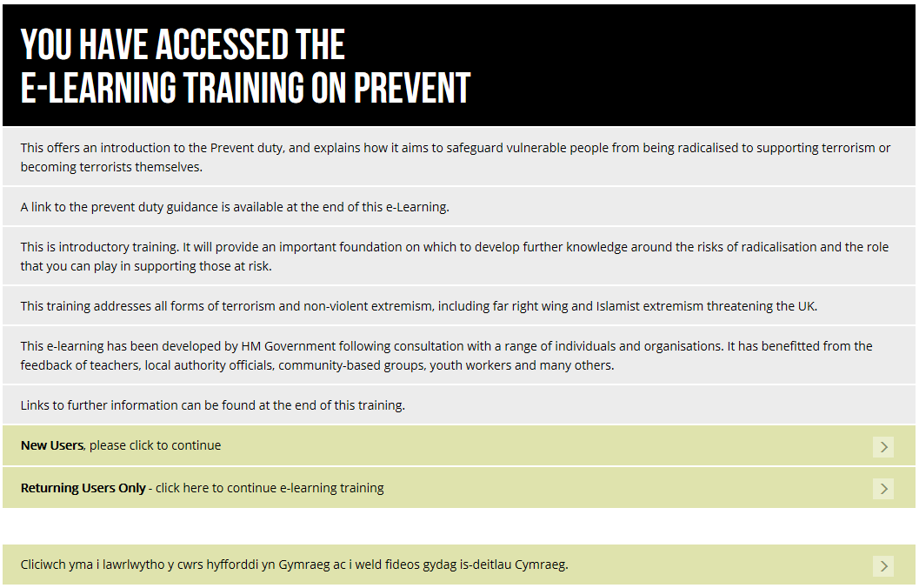
Please click on ‘New Users’.

- This page will appear:
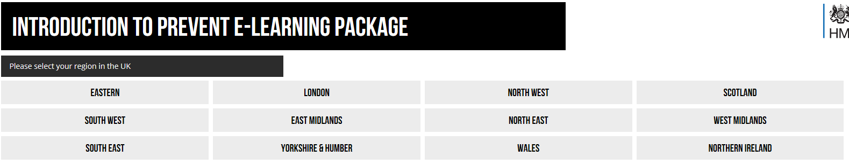
Select the region ‘South East’.

- This page will appear:
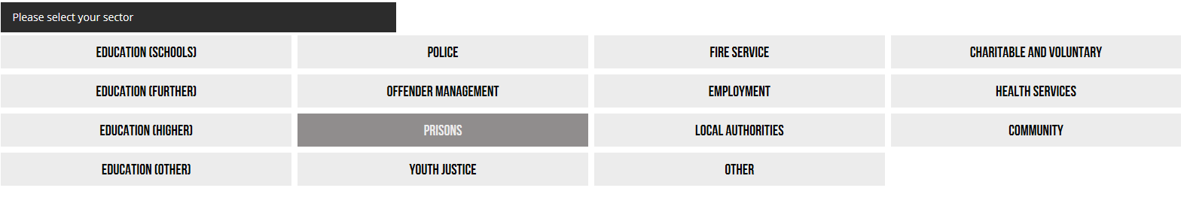
Select the relevant Education sector e.g. Education (Schools) for school staff, Education (Further) for college staff.

- This page or similar will appear:
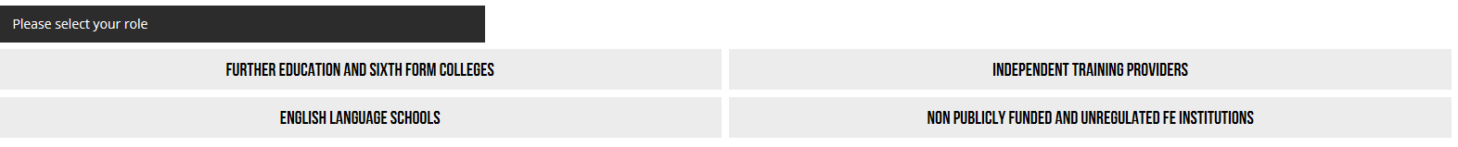
Select a role from the options that best fits with yours within Treloars.

- This page will appear:
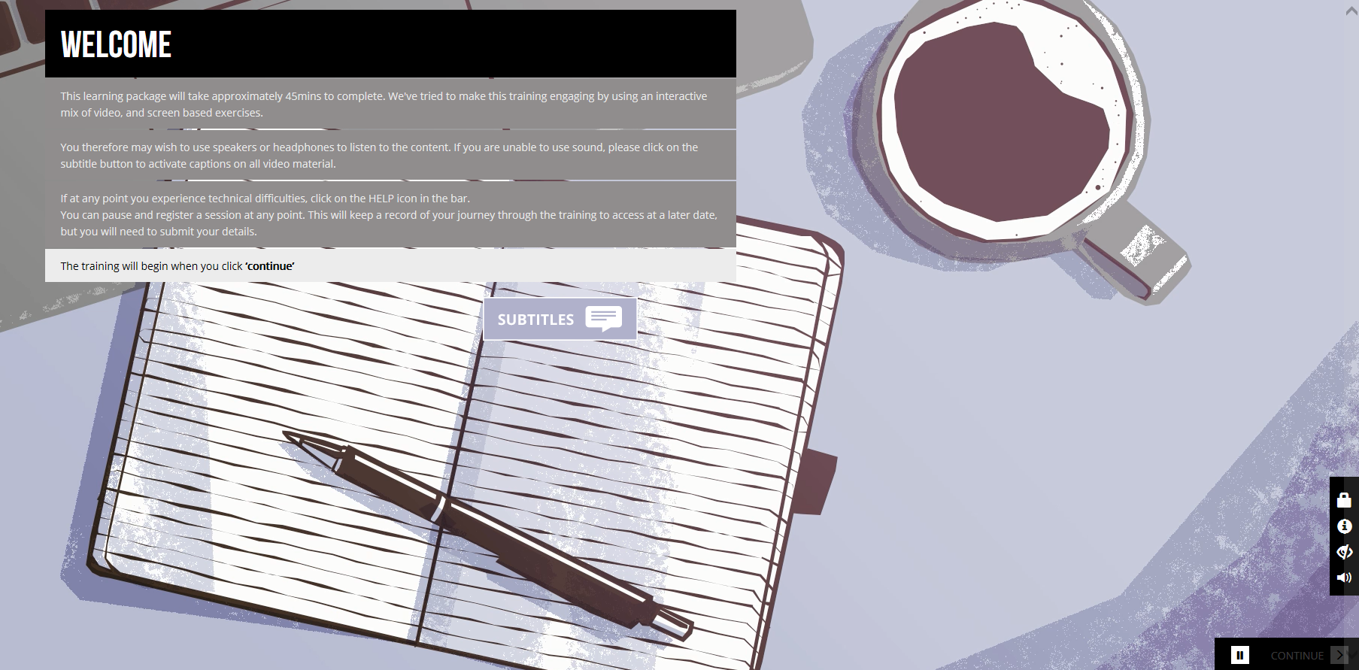

It will give you instructions as to what to do and if you don’t have sound facility you can use subtitles. The training should take 45 minutes.

- The course will ask you your previous knowledge:
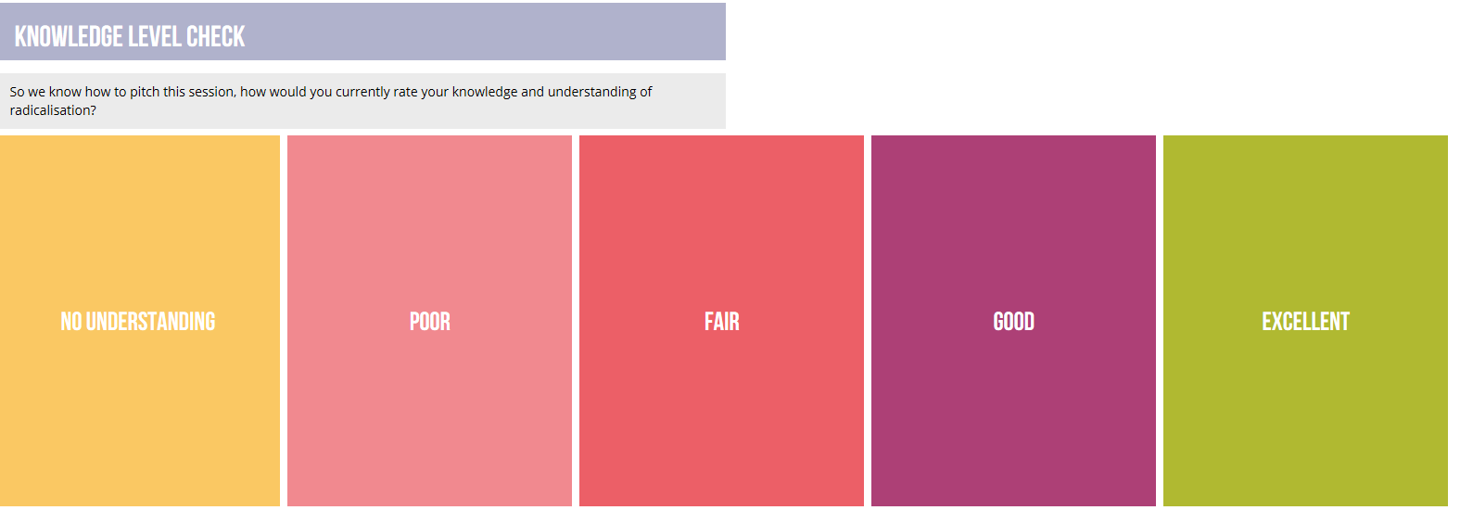

- You will be asked questions such as ‘Why have you been asked to complete this training’?
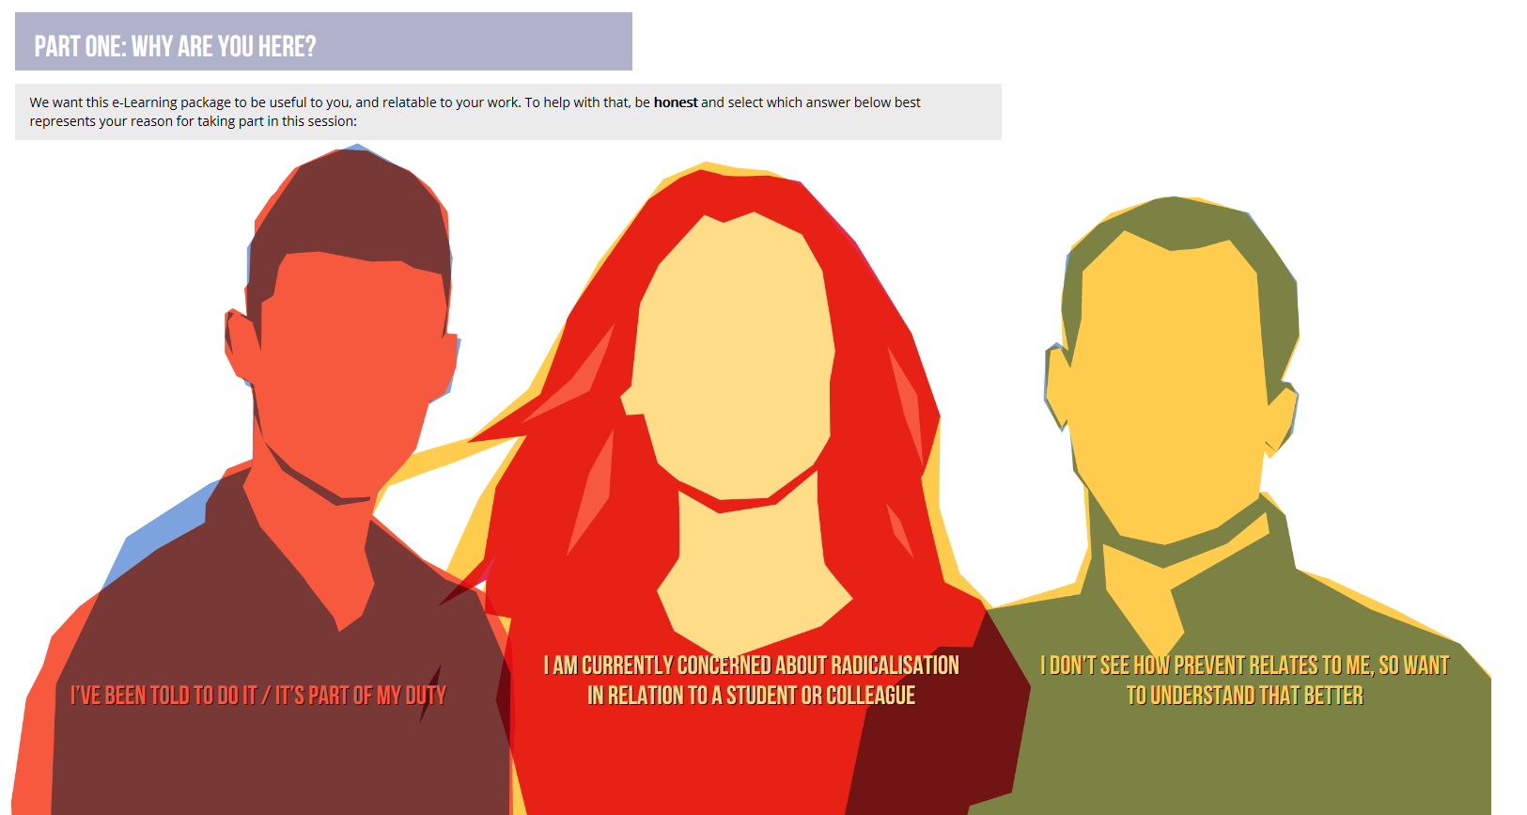

- You can click on the ‘continue’ and ‘next’ buttons throughout the course.

- After answering the questions the following page will appear:

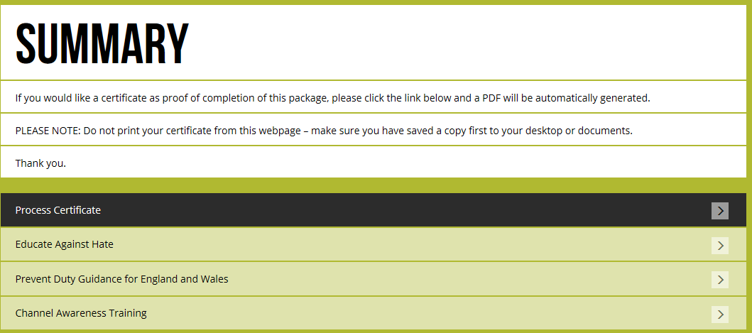

- Click on process certificate and type your name and organisation in and click process certificate.
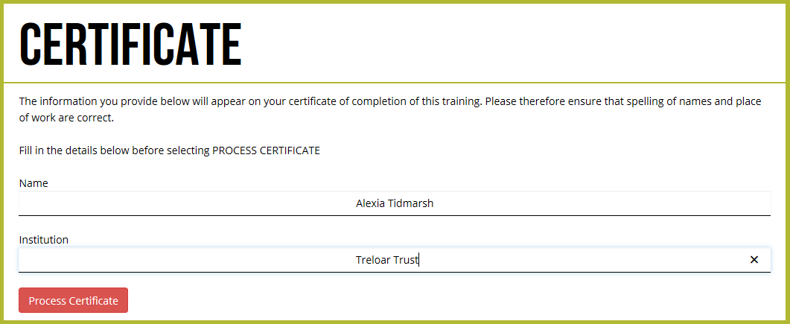

- The following will appear:
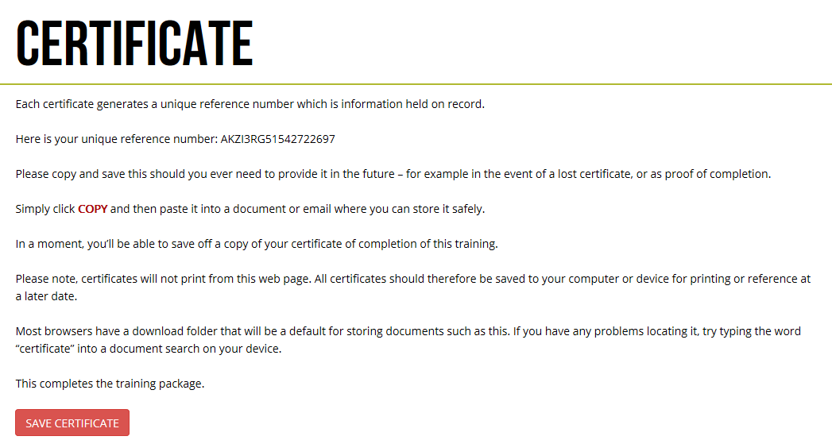

- Click on ‘Save Certificate’ and the following will come up:

Click on open and save the certificate copy somewhere on your computer.
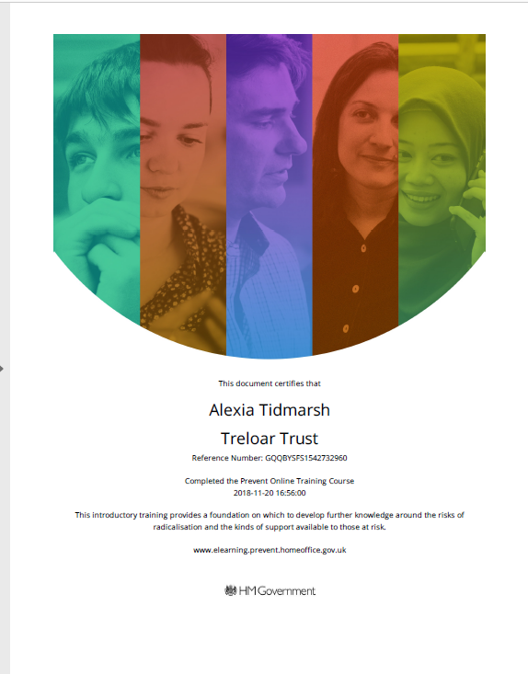
- Please email a copy of your certificate to the Training Department so they can update your record.

NOTE: Do not print from the website as this will not work, you must save the certificate before you will be able to print it.

