Top Tips for Learning at Home

Environment and Context
If possible it would be great to have a separate room or space where learning can take place as this creates a clear divide between ‘work’ and ‘play’ or ‘leisure’ time.
Try to minimize distractions, noise or music in the background.
Open a window and let fresh air in.

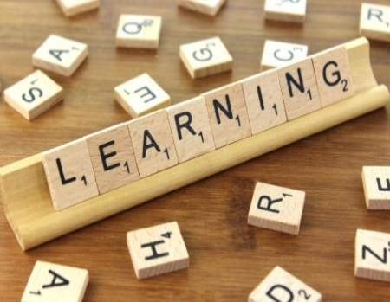
Learning Intentions – linked to targets
Talk about their learning (What this is, should be clearly indicated on the resource or activity sheet)
Talk about what the activity they are going to be doing.
Check what they know already so that you can help them to build their knowledge and understanding.
Recap previous learning. Perhaps ask the question ‘do you remember..?
Focus on one thing at a time and don’t try to do too much, think in small steps.

Questions
Ask open questions using; who, why, what, where, when and how.
‘Tell me about…’ is a lovely way to start a learning conversation or ‘what do you know about..?’

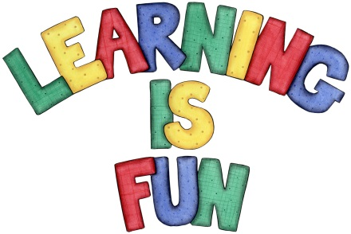
Create positive associations with learning
Be as enthusiastic and positive as possible.
Celebrate achievement no matter how small.

Take frequent breaks and don’t be afraid to STOP…… at any time

