Omegle
Internet Matters.org.

Omegle

Weekly Newsletter

Overview
Launched in March 2009, by a then 18-year-old, Omegle has recently become popular again due to the COVID-19 pandemic. This ‘virtual chat room’ offers random users to have unmoderated or moderated chats with one another from anywhere in the world.

What is Omegle?

Omegle, a video-chatting website that pairs random users identified as ‘You’ and ‘Stranger’ to chat online via ‘Text’, ‘Video’ or both. A user can also choose to add their interests, and Omegle will try to pair a user with someone who has similar interests. If not, you could meet anyone. Chats are anonymous unless the user states who they are, it’s free and no account sign up is required.
There appear to be many associated apps such as ‘Chat for Omegle’, ‘Free Omegle Chat’, ‘Omeglers’, but there is no longer an official Omegle app. All sites and apps appear to share the same features and purpose, but only some claim to be affiliated to Omegle and others state that they are not affiliated.
.Omegle Parents Online Safety Guide.

Who uses Omegle?
Omegle has a minimum age rating of 13 years or older with parental permission for under 18s. Omegle is particularly popular in the US, UK, India, and Mexico. It is also extremely popular among children and young people (as young as 7) as a lot of younger influencers come to Omegle from TikTok then share their experiences on TikTok creating a huge surge to the platform. The #omegle hashtag has approximately 5 billion views on TikTok.

Is Omegle safe?

Risk of sharing or viewing inappropriate content
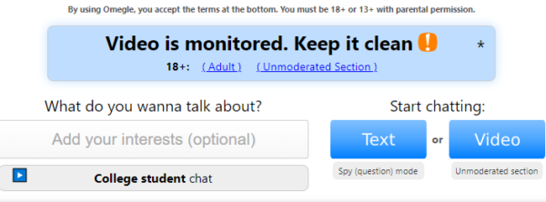
Omegle does not appear to have robust moderation nor is there a registration or age verification making them a potential target for online predators. Its site states “predators have been known to use Omegle, so please be careful.”
Children and young people may be asked by strangers to share their name, age, and location. So, it’s also important to talk to your child about sharing personal information online with strangers – some guidance is linked below.

A recent BBC investigation revealed sexually explicit videos and live streams (featuring minors as young as 7 or 8) which spread across the site during the Covid-19 pandemic. BBC has since alerted the relevant authorities.
According to the BBC’s investigation, schools, police forces, and governments have issued warnings about Omegle in the UK, US, France, Norway, Canada, and Australia.
There were also investigations into online child abuse on Omegle along with reports of racism, extremist views, scams, and cyberbullying.
Lack moderation on video chat
The video chat has an adult, moderated and unmoderated option that can be easily accessible by underage users. Clicking the button, the users will be directly on live video and text chat, without warning which unfortunately allows for children to be easily exposed to potential risks in a matter of seconds. Additionally, the video chat opens up the possibility for footage to be recorded and distributed without the user’s consent.
Types of chat options:

- Adult – anyone can access this which contains heavily explicit content. The user only needs to confirm by clicking a button then they’re redirected to an external adult pornography site
- Moderated chat – according to Omegle’s Disclaimer they moderate chats and say “… moderation is not perfect. You may still encounter people who misbehave.” However, they do not state how it does this effectively or frequently
- Unmoderated chat – this option comes with a warning box advising the user they need to be 18+ but an underage user can easily click ‘OK’ and they are allowed in. Users are highly likely to encounter risks such as online grooming, sexually explicit and violent content
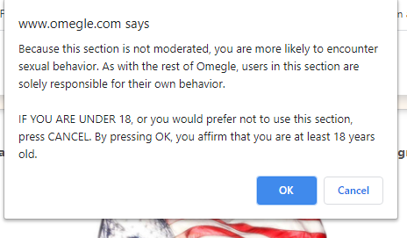
Anonymous text chat
The text chat has a ‘spy’ function where users can either be the ‘spy’ and log on as a hidden 3rd party in a text chat between two people.
The ‘spy’ can then ask the other two users to discuss a particular topic/question and view their replies. Alternatively, a user can be the participant and discuss the question with another user.
A ‘spy’ can exit without ending the chat between the other two users.

Does Omegle have any parental controls?
Although there are prompts to encourage the safe use of the platform, there are no parental control settings on the app.
According to Omegle, they monitor conversations, but despite stating ‘video is monitored, keep it clean’, children and young people visiting this section are likely to encounter numerous other users engaging in sexually explicit chat and activity putting them at risk.
There are no instructions on how a user can report other users or content, even though Omegle’s Disclaimer advises that users can. There is also no block or mute feature either nor is there a robust enough system of monitoring or filtering video/text chats, so it’s important to enable parental controls on their phone and/or your home broadband.
In addition to the potential online risks, parents should also be aware of the danger of these conversations moving from online to offline and potential meetups.
It’s important to understand that Omegle connects kids with strangers of any age, so we would advise parents to consider restricting the use of the platform for children under 18.

Ways of keeping children safe online

- Having regular conversations with your child’s online life is an important way to keep them safe online – such as chatting to strangers online
- Set up parental controls – you can enable filters, block certain websites and much more. Head over to our Parental Controls hub for more information
- Report it! If you suspect a child is a victim of online sexual abuse, report it immediately to CEOP or contact the police

