Asthma Online User Guide

- Go to Supporting Children's Health – An Education for Health resource

- Click on Register:
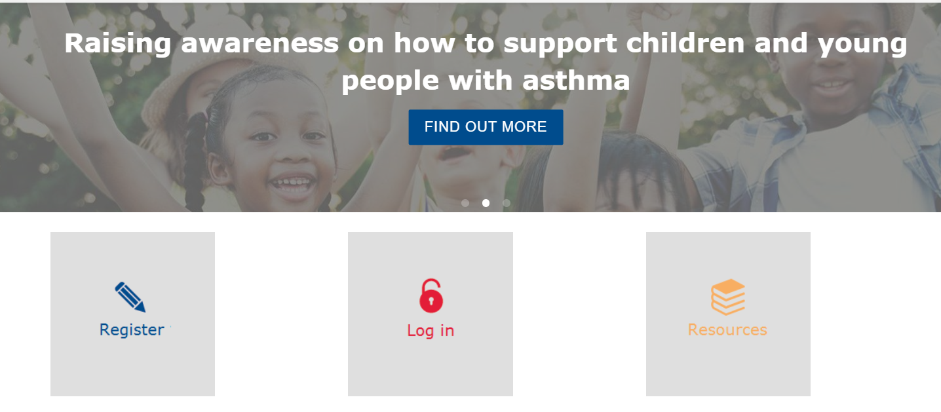

- Add your details and set a username and password:

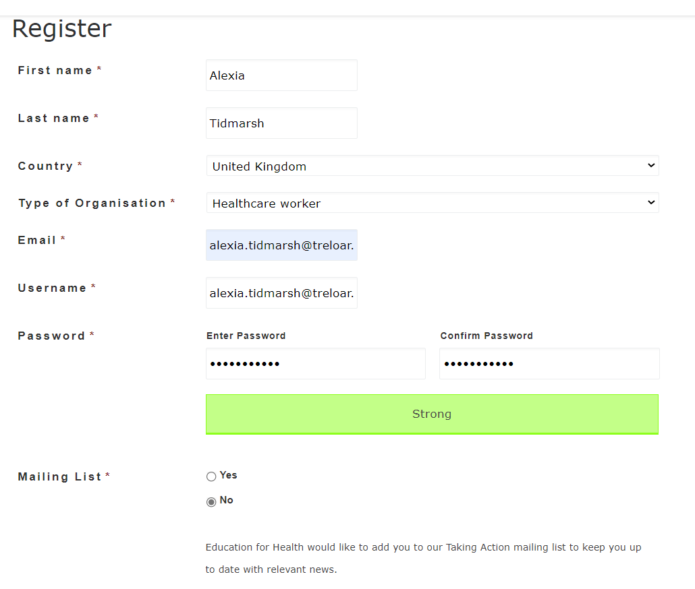

- Click on login with the details you have just set up.

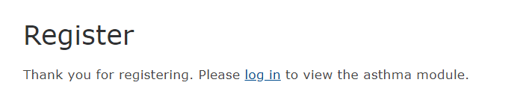

- Click on Asthma module at the top:

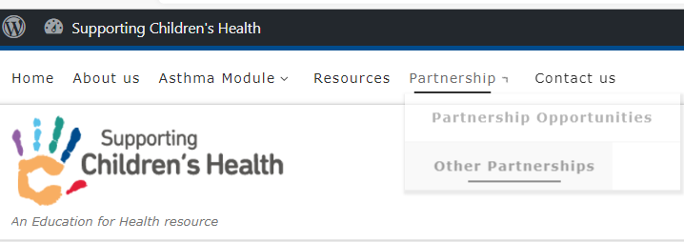

- The following description of the course will come up.
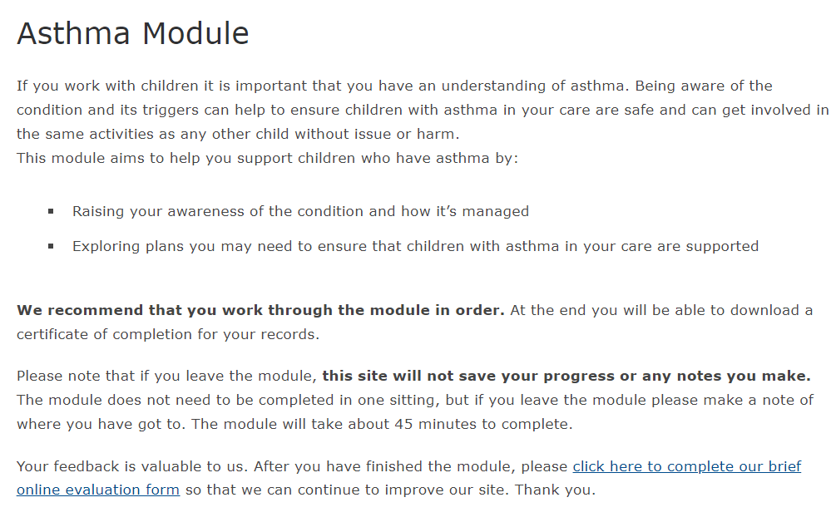

- Click on Asthma Elearning Module on right hand side:

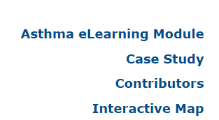

- The course will look like this:

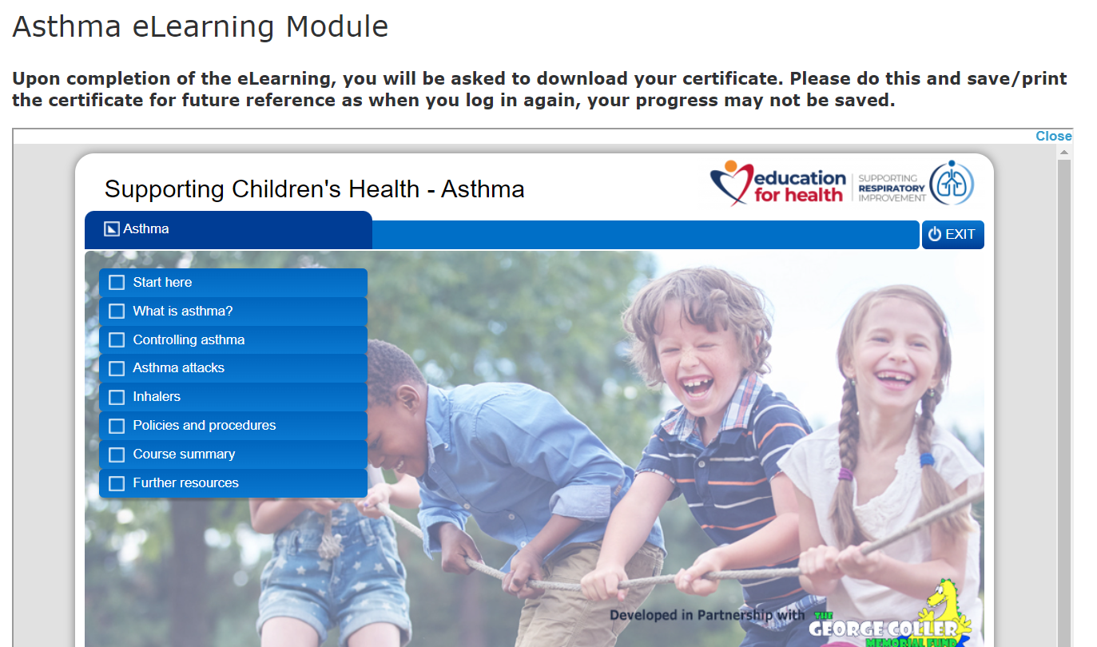

- Work through the modules in order and it will show what you have/ have not completed as you go through the course.

- When you get to the following page, you will be able to retrieve your certificate. Click to confirm you have completed all the pages and click to download your certificate. Please save the certificate.

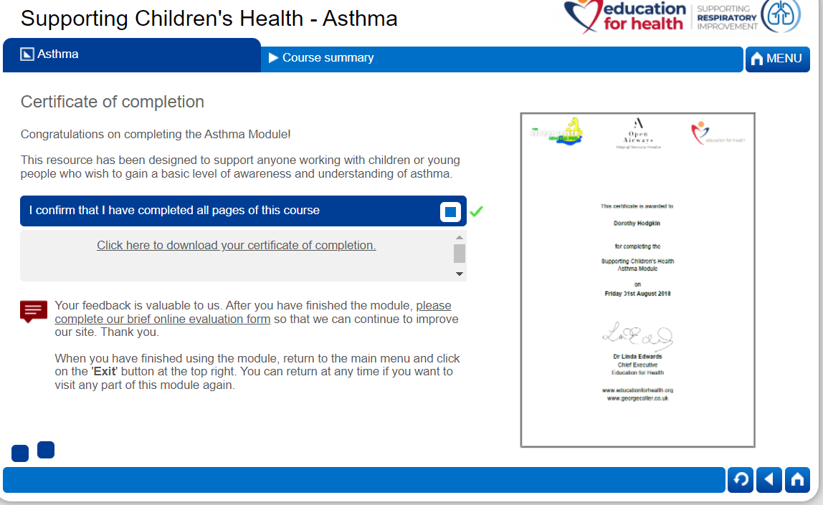

- The certificate should look like the following. Please email a saved copy of it to the Training Department to log.

